Press
27.05.2020

cirp GmbH
Service provider for the production
of prototypes and small-run series
cirp develops a reusable face mask with the support of EOS and MANN+HUMMEL
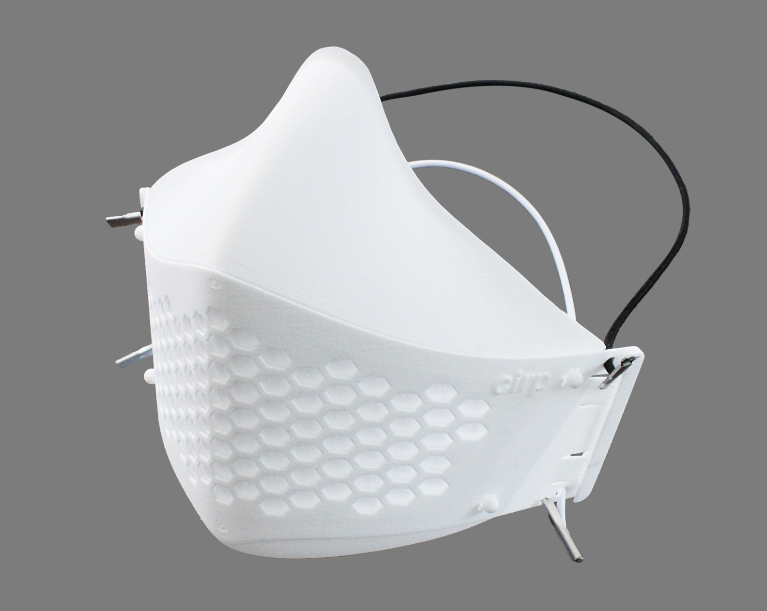
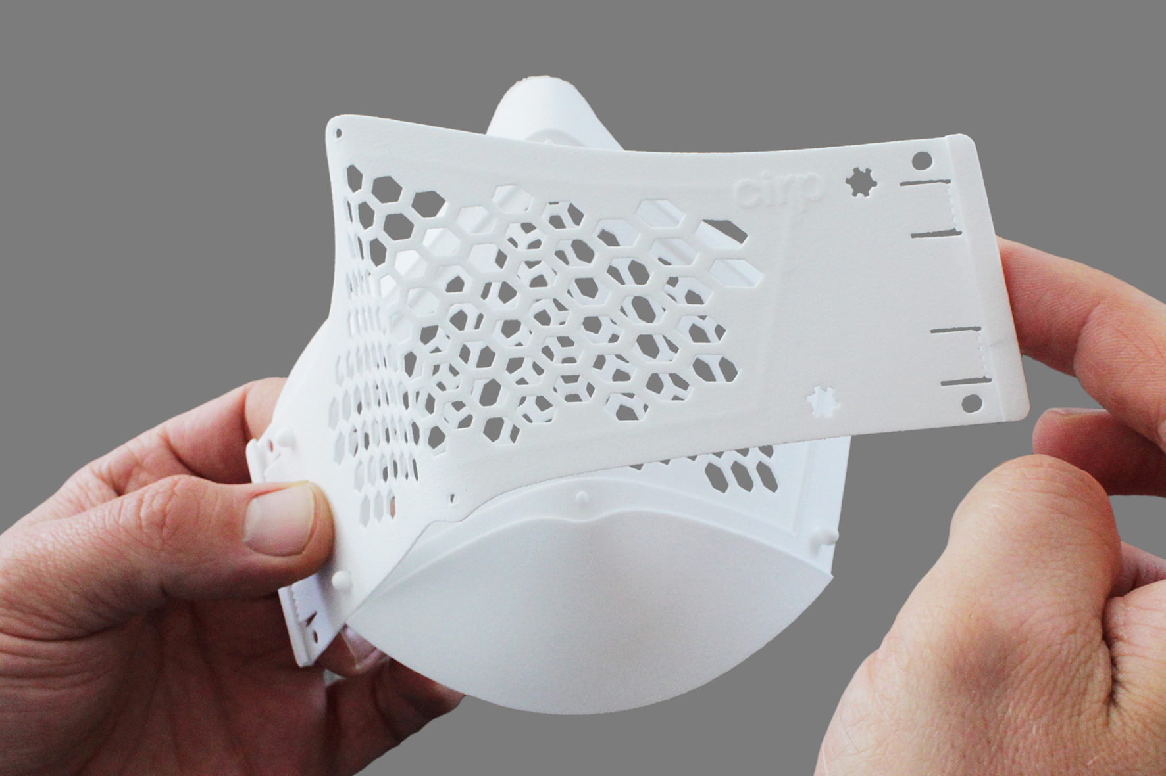
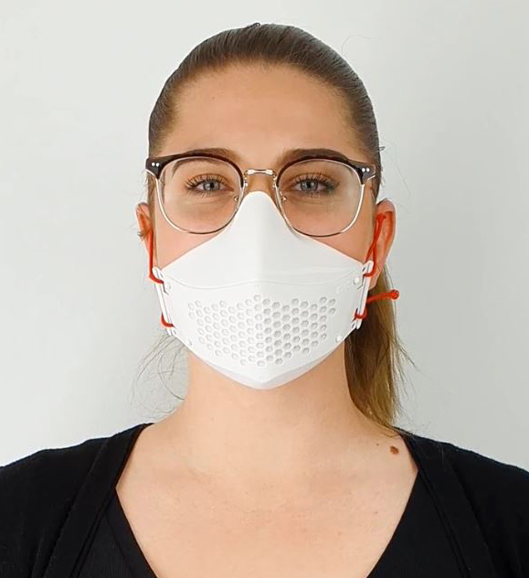
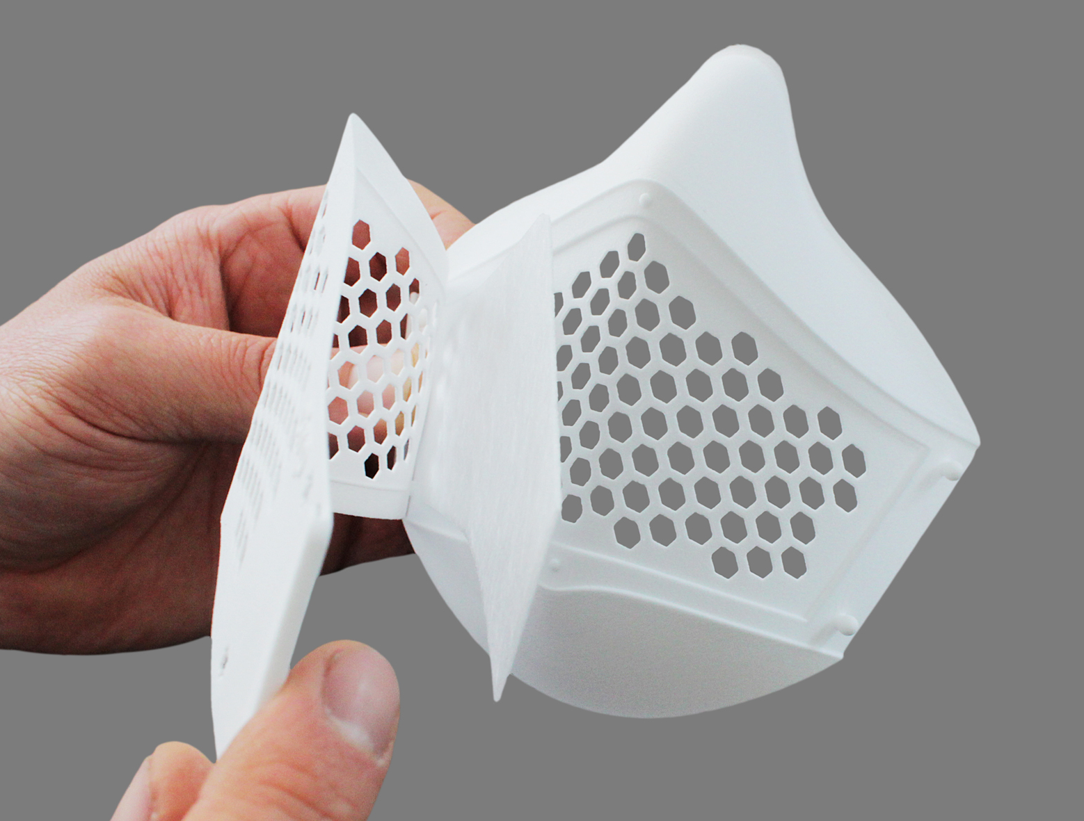
cirp GmbH, a specialist for additive manufacturing and rapid tooling in Heimsheim, Baden-Wuerttemberg, has created a reusable face mask to slow down the spread of the Corona Virus SARS-CoV-2 with the support of EOS and MANN+HUMMEL. The mask stands out thanks to its replaceable filter and because it is easy to clean and disinfect. In addition, there are up to four different ways of donning the mask. While the mask was being quickly developed and 3D-printed, cirp took into consideration the feedback given by medical centers and nursing homes, as well as by Prof. Dr. med Dirk Weyhe, director of the Clinic for General and Visceral Surgery, University Clinic for Visceral Surgery at Pius-Hospital Oldenburg, Medical Campus University Oldenburg, to design a mask suitable for a wider range of applications. A large number of masks can be ordered immediately.

cirp GmbH is an expert in quickly delivering plastic components for prototypes and in bringing them into series production for more than 25 years. Although manufacturing personal protective equipment was not part of the portfolio so far. “Initially I wanted to produce masks to protect our employees. But then we started receiving multiple requests from different organizations that were desperately looking for protective equipment for their employees” commented Ralf Nachreiner, managing director at cirp GmbH. The company saw the need as an opportunity to develop and supply a reusable mask for a broader group.
In the battle against Coronavirus, cirp has developed a face mask that is reusable thanks to its replaceable filters

From the first design, through the various development stages of the prototypes and to the first 100 manufactured face masks less than seven days went by. “3D printing has displayed its strengths here, because additive manufacturing enables a flexible and quick production” added Ralf Nachreiner. Different people from various areas tested every intermediate stage and their feedback was used as impulse in the development. One of the main challenges was to obtain a suitable filter material. In particular, MANN+HUMMEL, expert in the field of filtration, provided the proper filter material to produce the masks. It was manufactured exclusively for cirp GmbH within a few days. “In the past, cirp has always been impressive and supported us when it came to supplying tools and components in just a few days’ time. That is why we got a move on it to provide them with the adequate filter material.” said Martin Klein, VP Engineering Filter Elements at MANN+HUMMEL. The replaceable filters are cut to size with a laser cutter at cirp GmbH.

The mask is suitable for the healthcare area and care sector, for rescue and emergency teams, as well as for many others. The mask stands out thanks to its simple handling and reusability; since the filter can be removed and replaced with a new one. In addition, there are up to four different ways of donning the mask, which enables the user to wear the mask according to his or her personal preference. Another remarkable feature is that it can be disinfected with surface disinfectants or using a steam sterilizer. The mask can be used while wearing corrective eyewear, goggles or under a face shield – the latter being as well manufactured by cirp GmbH. Its lightweight of ca. 20g ensures a high wearing comfort. Currently, the responsibility for its use lies solely with the wearer or the employer. cirp GmbH is striving to get the approval of a further developed, multi-component, injection-molded version of the mask for medical use.

The masks are manufactured at cirp GmbH with the powder bed-based 3D-printing technique Selective Laser Sintering (SLS) on a 3D printer by EOS. First of all, a thin layer of powder is dispersed above a platform. Then, a powerful laser beam melts the powder exactly on the sports determined by the computer-generated design data. This process repeats itself over and over again until the component is completely build, layer by layer. EOS, a company based in Krailling, Bavaria, supports cirp’s initiative supplying their special powder PA2200. Material supply for relevant COVID-19 products is bound to special terms and at cirp, this powder has been used so far to manufacture the masks and some components of the face shield. That is how we could counteract the current healthcare supply shortage. “We are very pleased to see how our longstanding partner EOS has demonstrated its unbureaucratic solidarity towards our initiative,” concluded Ralf Nachreiner. “I am very proud on how fast and closely we are currently collaborating with clients, suppliers and scientific institutions to provide items that until now were not part of our core business”, he added.

Several 100 masks can be manufactured daily. It is possible to customize the mask upon request with a printed logo or a special color. Packaging units containing 100 items as well as replaceable filters are available at cirp GmbH. In the present situation, the companies cirp GbmH, EOS GmbH and MANN+HUMMEL are committed to making their own contribution to contamination control and will further pursue innovation to support the healthcare system given the current circumstances.

For more information visit cirp.de

About cirp
Since 1994, cirp GmbH produces models, prototypes and small-run series in plastic using therefore generative procedures such as stereolithography, selective laser sintering or PolyJet. Equipped with CNC processing centers and the latest injection molding machines with a clamping force of up to 4500 Kn, our company meets the requirement to offer test-standard pieces, and often bridge the gap before the large-scale series tool. Even before finished data is available, our design department relies on modern CAD/CAM Systems and 3D scanning technologies to help its clients. As partner in various collaborative research projects, cirp GmbH is as well committed to continuously shifting and expanding the possibilities and limits from the idea to the product. (www.cirp.de)

About EOS
EOS is the leading technology provider worldwide for industrial 3D printing of metals and plastics. Founded as an independent company in 1989, we are pioneers and innovators for integrated solutions in additive manufacturing. Its product portfolio of EOS systems, materials, and process parameters gives customers crucial competitive advantages in terms of product quality and the long-term economic sustainability of their manufacturing processes. Our portfolio also includes worldwide service and comprehensive consulting. (www.eos.info)
About MANN+HUMMEL
MANN+HUMMEL is the global market leader in the area of filtration. The consortium, based in Ludwigsburg, develops filtration solutions for industrial applications, clean indoor air in industry and public spaces and the sustainable use of water. With more than 20.000 employees in over 80 locations around the world, the company generated an annual turnover of about 4 billion in 2018. The portfolio includes air filter systems, suction systems, liquid filter systems, technical plastic parts, filter media, cabin filters, industrial filters as well as membranes and modules for water filtration, wastewater treatment and process applications. (www.mann-hummel.com)

